Epistle from FWCC Europe & Middle East Section Annual Meeting
Held at Woodbrooke Quaker Study Centre, Birmingham, 4 – 7 June 2015

To Friends everywhere, Loving Greetings - Srdečné pozdravy,
kærlige hilsener, Hartelijke groeten, Lämpimin terveisin, salutations affectueuses, Liebe Grüße, Szeretettel köseöntzük, Calorosi saluti, Hjertelig hilsen, Serdecznie pozdrawiamy, сердечный приветвие, saludos cariñosos, kära hälsningar, Beannacht Dé oraibh, salut amics, salamu za upendo

This year's gathering of Europe & Middle East Section comprised over 80 participants, and was enriched by the presence of members of FWCC’s Central Executive Committee, as we have gone about our business and our theme, looking at ourselves as pilgrims on a journey whose next stage will be the 2016 World Plenary Meeting in Pisac, Peru.
We have explored what this means to us as individuals, meetings, and as the world family of Friends. In plenary, in pairs, and in groups, we have asked: where have we come from, where are we going and how can we support one another as we travel? It has been a joy to consider these queries together at the nourishing watering hole of Woodbrooke, before continuing on our paths, whether to Pisac, or elsewhere. Looking forward, it has been valuable to contemplate the signposts pointing us towards action.
Ben Pink Dandelion’s keynote address reminded us that Quakerism is inherently collective as well as diverse. He challenged us to be ready to speak out our personal awareness of the divine but also open to listen from our hearts to those whose religious experience, however differently expressed, might emerge from the same deep place. We were struck by his suggestion that the Amish query – does this action build community? – can be an excellent way of testing discernment about things great and small.
We are, as our speaker said, a ‘do it together’ religious community and we long to make that more of a reality, especially for very small groups and those who are lone Quakers within their area or even larger region. So it was wonderful to hear, in our worship for business, of the exciting opportunity which has opened for EMES. The Joseph Rowntree Charitable Trust has entrusted EMES with the administration of a Small Grants Fund. Its aim is to support European & Middle East Quaker groups in finding ways to grow our Quaker identity. This spirit-led generosity and trust greatly encourages us to look forward to the strengthening of our Quaker witness across the Section.
The joy of our meeting included early morning exercise for some and Experiment with Light for others; on our final evening we joined in dancing and singing together. At evening epilogue we have been led in varied and engaging worship by Friends from the Africa, Asia West Pacific and Americas Sections. The opening presentation and later excursions to Quaker places and projects, have given us a glimpse of Central England Quakers’ vibrant faith in action.
In all these things we have felt blessed that the Spirit of God works to unite us. While across the FWCC Sections our backgrounds may be very different, we share a loving trust. Our religious quest, our testimonies and our commitment to a life of faith in action bring us into unity that is deeper than words or outward uniformity. We give thanks for the deep ministry experienced in our worship. We are glad to share this journey, experiencing God in our loving relationships. As we draw strength from the inspiration of our intense experience here, we know it will sustain us for our pilgrimage. This refreshment is not just for us. We want to give to others what we have discovered through meeting one another and exploring our richly diverse ways of expressing our faith and experience. ‘To give the message, we must be the message.’ (Thomas Kelly)
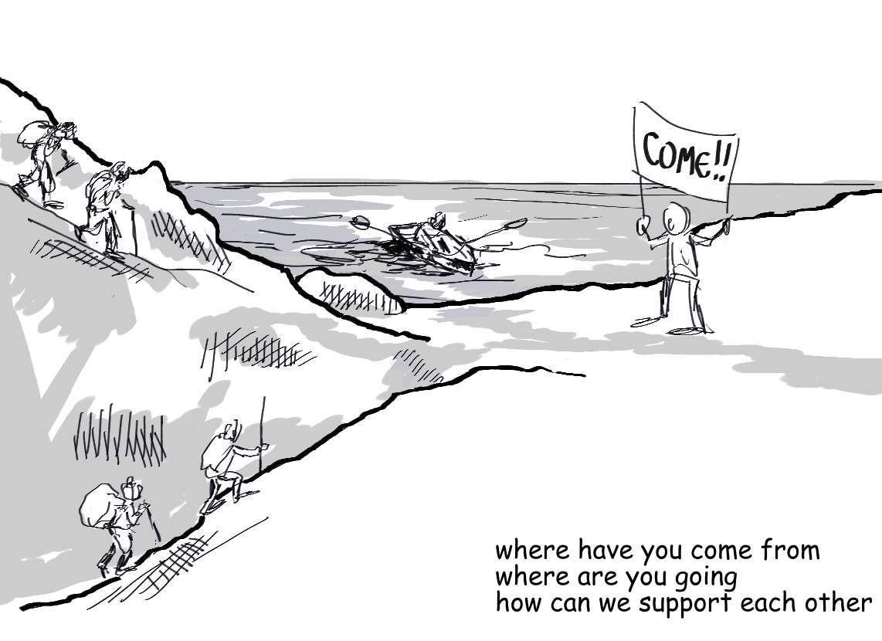
Signed in and on behalf of FWCC-EMES
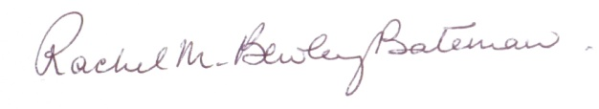
Rachel M Bewley-Bateman, Clerk

